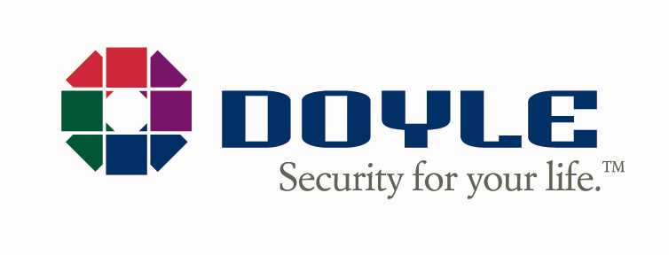
July 1, 2022

Dear Valued Customer of Line Security,

On behalf of our entire team, I would like to welcome you to Doyle Security Systems! We are thrilled to have you join the Doyle Security family!

As you know, the Line Security team is joining forces with Doyle as of July 1, 2022. Just like Line Security, we are a New York-based company with headquarters in Rochester. We are excited and honored to continue to provide you with the highest quality protection and great service you are used to receiving from Line Security.

Let us get to know each other! To start, it is worth noting that Line Security and Doyle Security Systems have a lot in common. In our industry, both of our companies are well known for providing premiere service. We are eager to tell you about some new features and benefits you will receive from our team at Doyle Security:
- An award-winning Emergency Response Center that is both UL-Listed and Five Diamond Certified.
- An all-star staff that receives the highest level of training available for our industry.
- A monitoring center named an “Emergency Response Center of the Year” by The Monitoring Association.
- A team of Emergency Response Center supervisors who average more than 15 years with our company and are always ready to be at your service.
- The very latest technology and capability in residential and commercial systems, including video, access, medical alarms and home automation.
- A family-owned business that is recognized as one of the “Best Companies to Work for in New York” for three years running.

Doyle Security has been family-owned and operated since 1919, so you can rest assured knowing that our experience in the security industry will provide you the best protection available. In addition to our Fishkill location, we have offices in Syracuse, Rochester, Albany, Buffalo, Olean, Watertown and Catskill, New York as well as Erie, Pennsylvania. We have worked tirelessly for more than 100 years to ensure that all of our customers receive the best possible security with the greatest reliability available in our industry!

If you have any questions, please do not hesitate to contact us at any of the support options included below. You can also receive periodic updates about the merger by filling out the form on our website at Line.www.GoDoyle.com/Line.

Again, we are so happy to welcome you to our Doyle Security family. We look forward to providing you with all of your security needs.

Sincerely,

John G. Doyle, Jr.
President and CEO
Doyle Security Systems, Inc.
Customer Support
Email: LineSupport@GoDoyle.com
Web: www.GoDoyle.com/Line
Phone: (585) 242-1555

